Troop 39 – Canoe To Canada – A High Adventure Trip to the Boundary Waters of Minnesota
By Geoff Sessa – ASM Troop 39, CAI
I recently completed a 5 day canoe trek in the Boundary Waters of MN along with 8 leaders and 15 Scouts from Troop 39 in July. One of my Wood Badge Ticket goals this year was to become a BSA Certified Angling Instructor and help improve chances of catching fish for our Scouts and Leaders on this trip. I became a CAI this spring after attending Pat Curley’s class at Camp Powhatan in VA. I later met with CAI area lead John Woodall III who helped me with local knowledge. John has over 70 trips to the Boundary Waters under his belt and also trains staff at Norther Tier. I also contacted CAI Frederick Hodge who also was a tremendous help. After completing research, I wrote the attached “2019 Canoe to Canada Fishing Guide” and presented to Troop 39 as part of our training preparation for the trip.
I am pleased to report that this training was a success as measured from the feedback I received from our crew of Scouts and Adult Leaders. As an example, Ian Williams (Life Scout, former Troop 39 Senior Patrol Leader and only Scout that has done this trip in the past) reported that his crew only caught 1 fish on his last Canoe to Canada Trip and his crew caught 43 fish on the trip this year!
I think the greatest benefit that the training provided was confidence. Our crews knew what gear to bring, how to use it, and knew what type of fish they were going to catch. Many thanks to Pat Curley, John Woodall III, and Frederick Hodge for sharing their knowledge and offering support.
Here are a few pics from our adventure. Fish On!

Day 1 – The adults had a chance to fish first as Scouts prepared Camp!
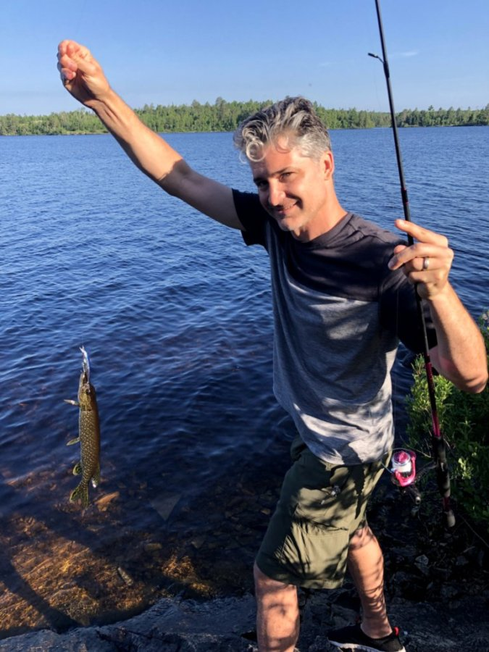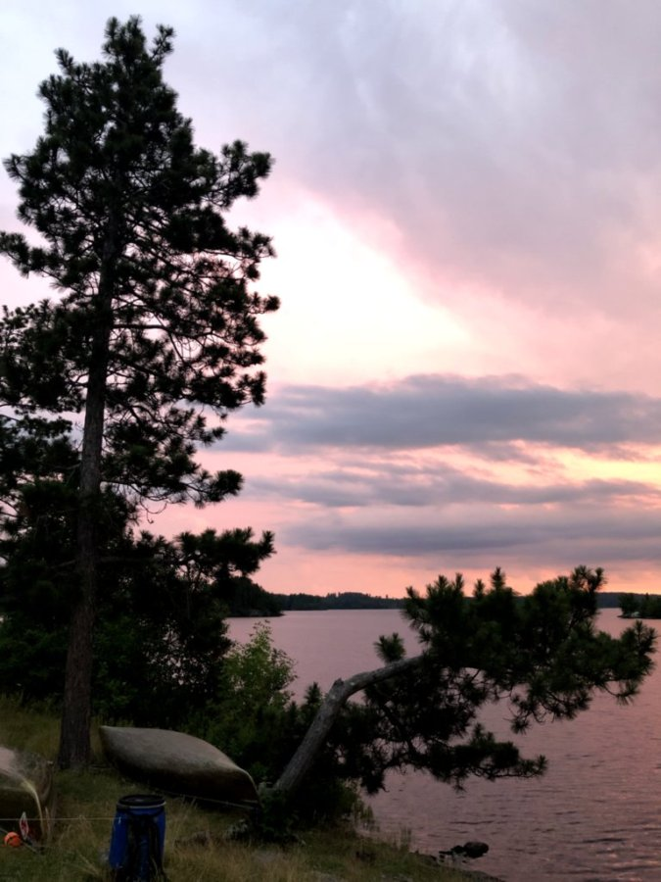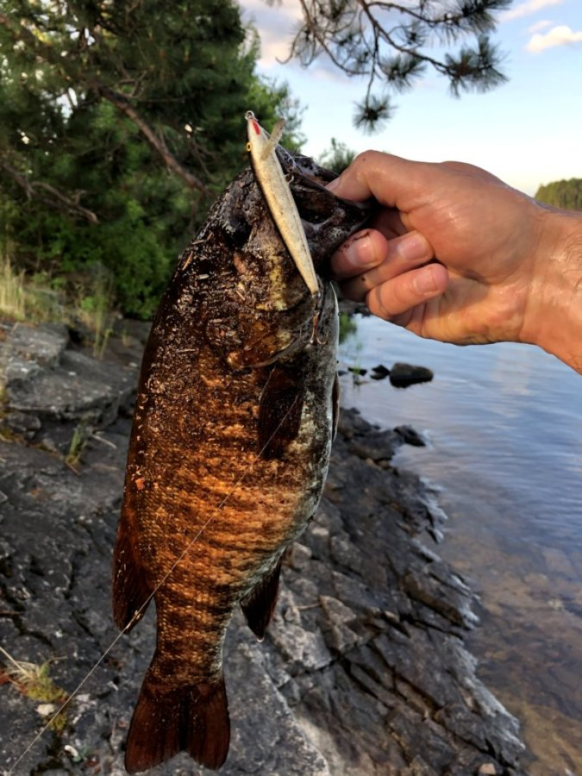

One of many portages.
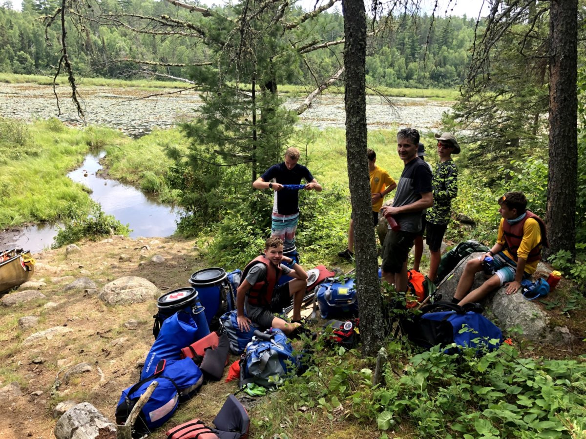

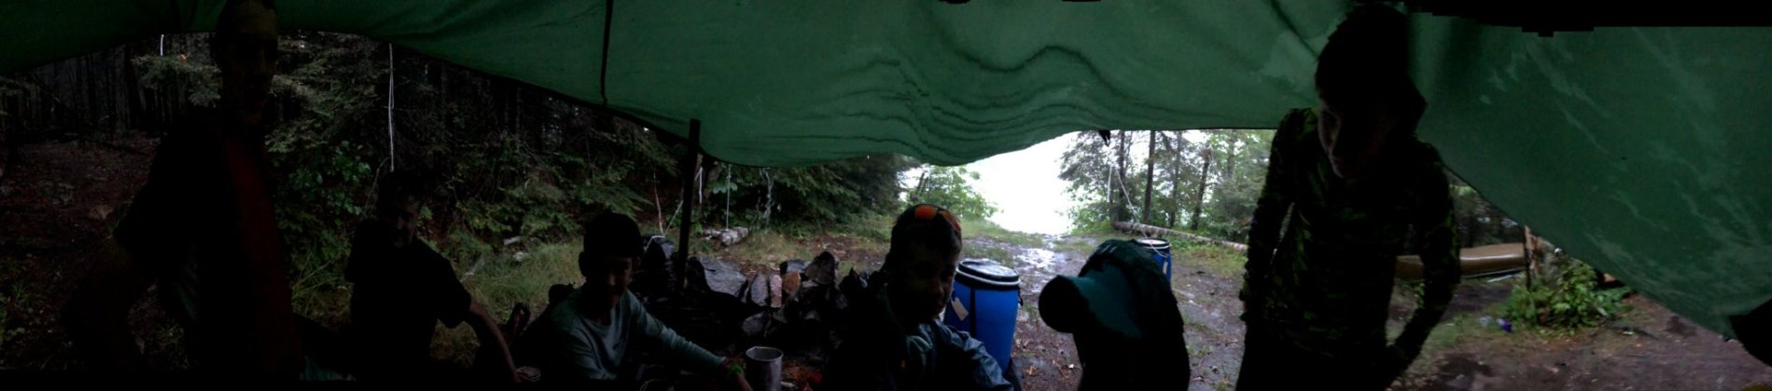

Scouts in action!
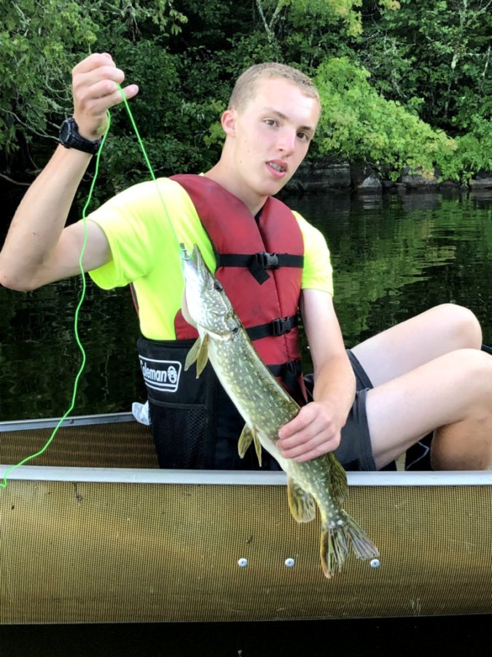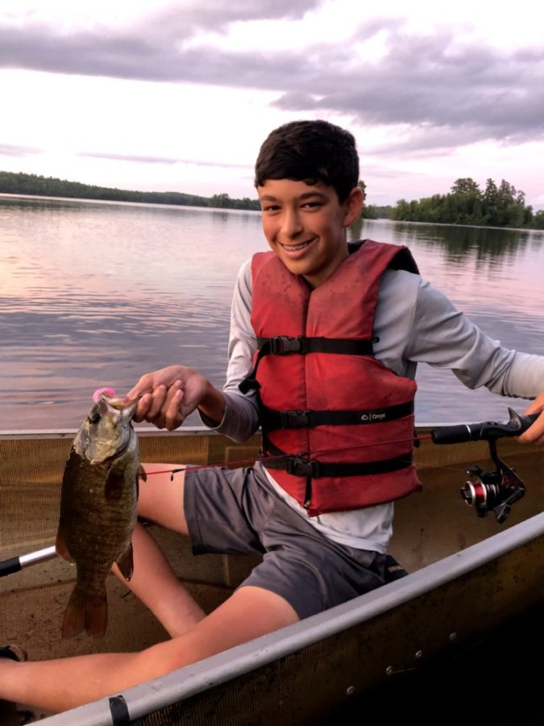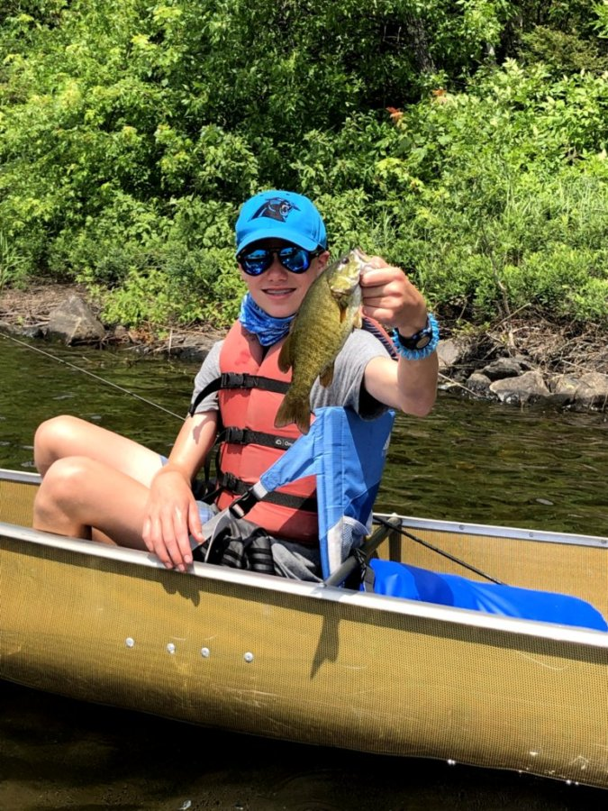

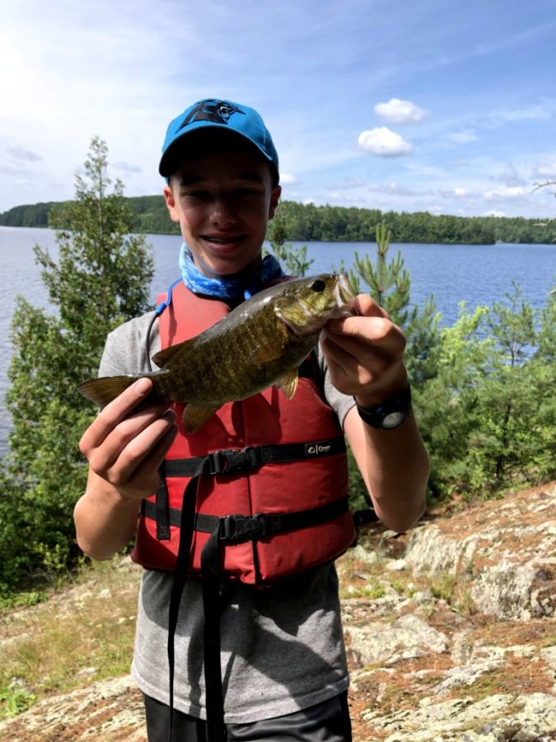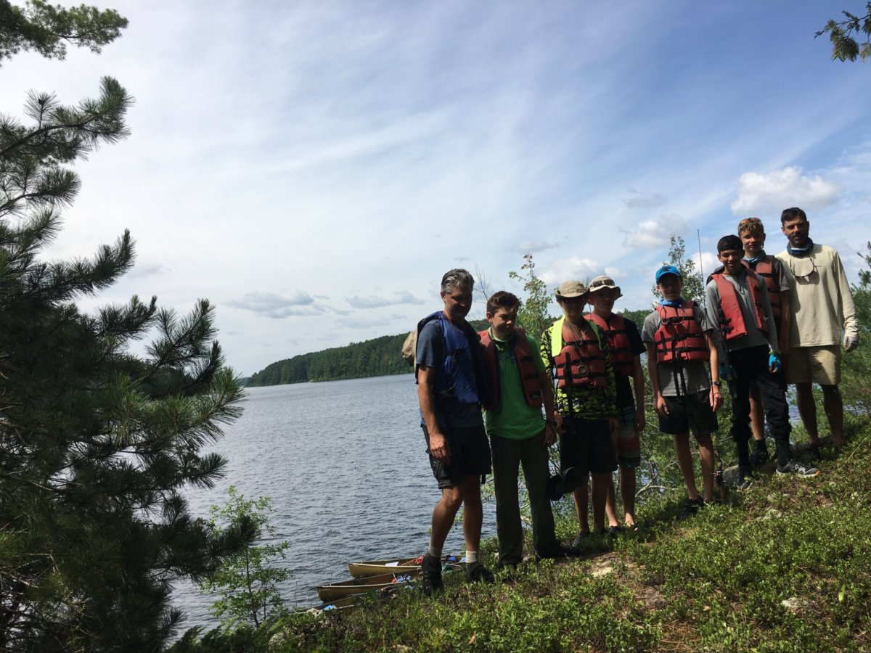
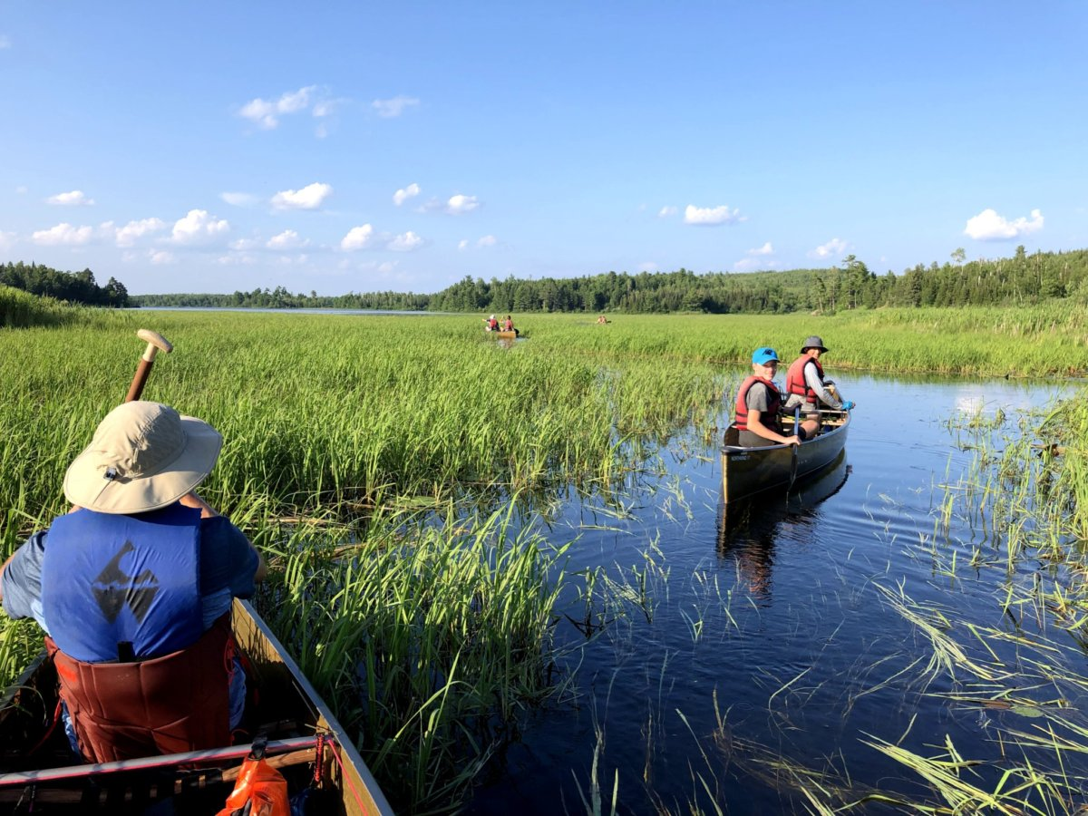
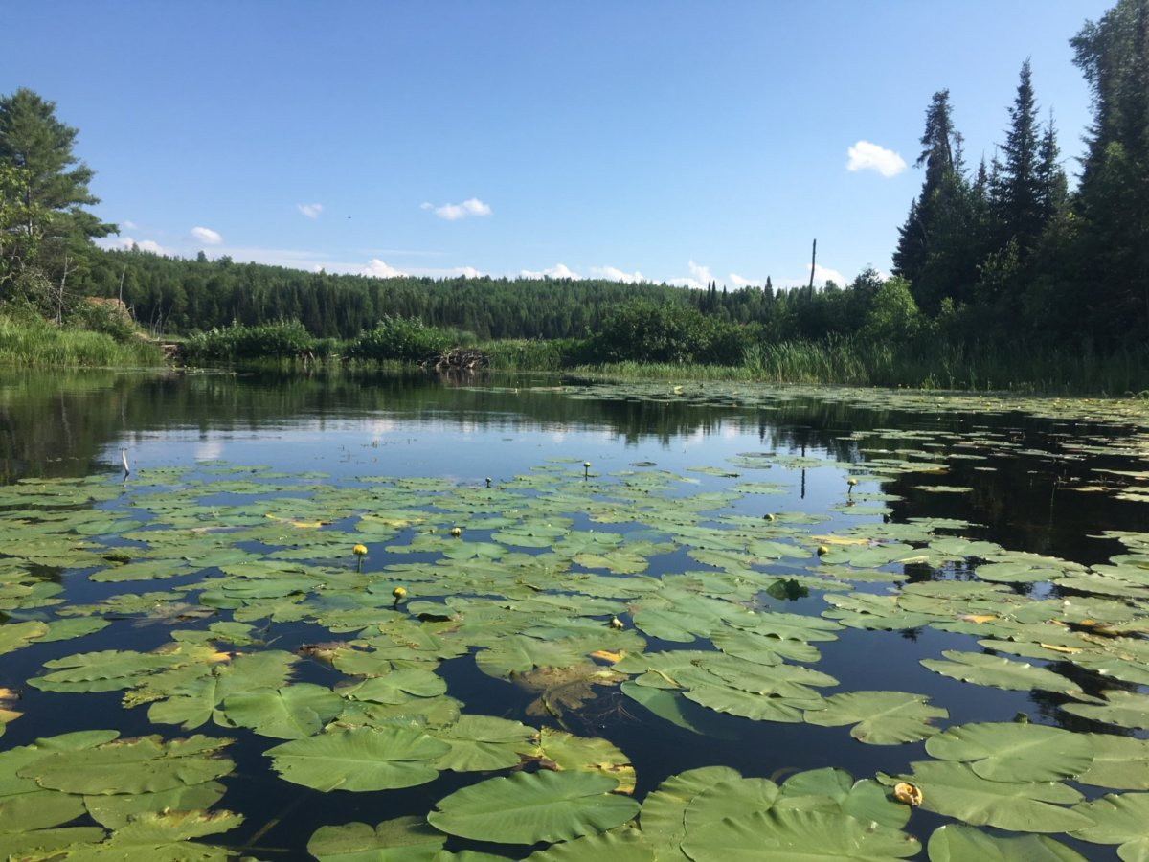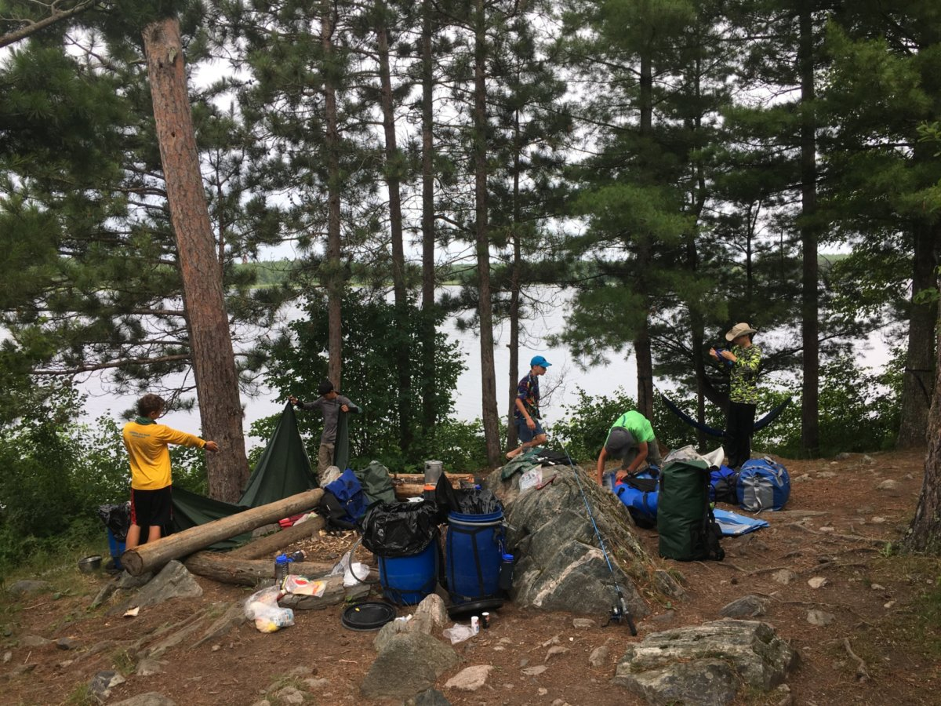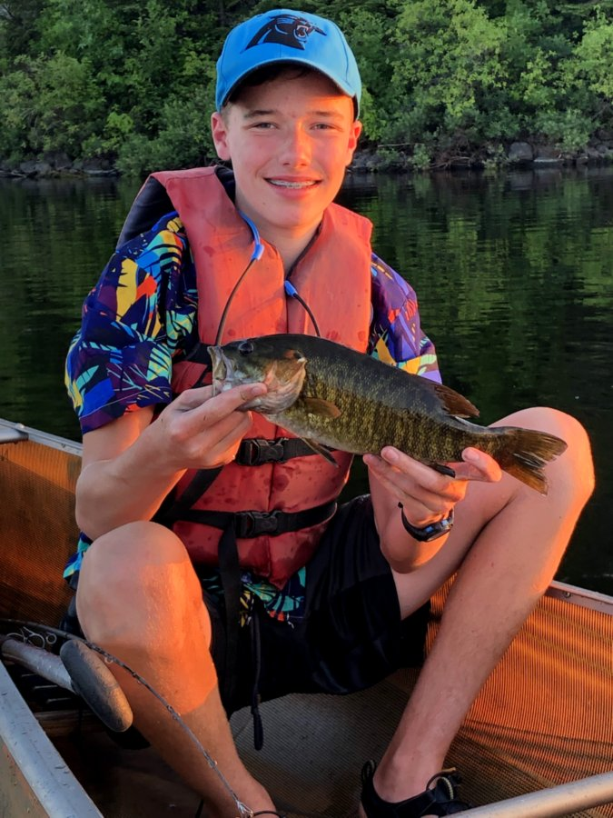

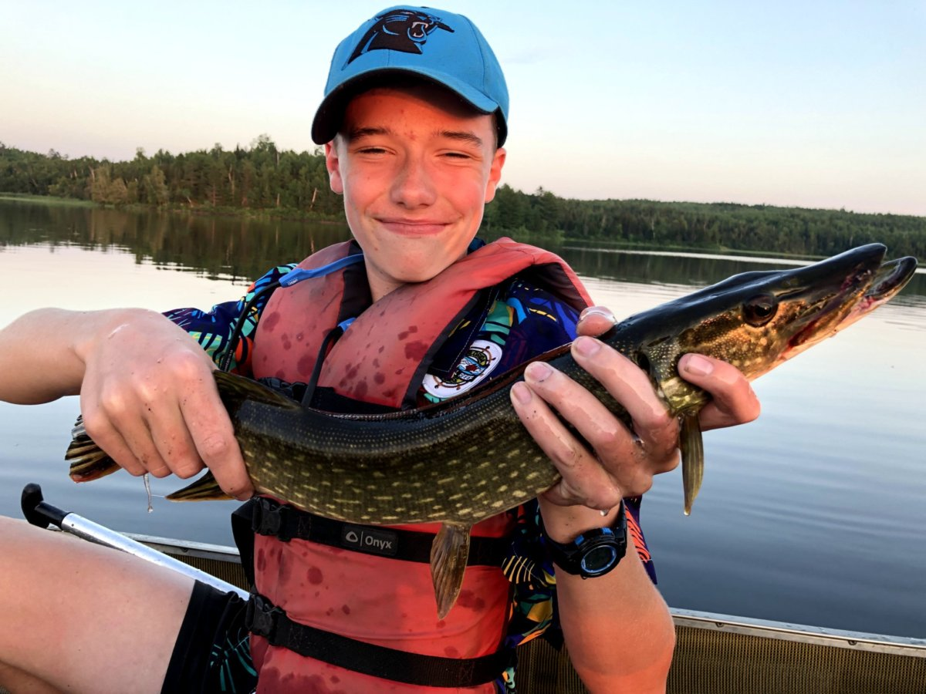
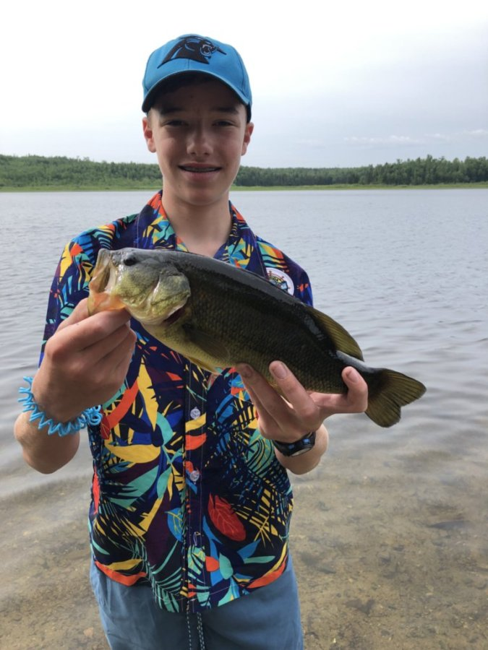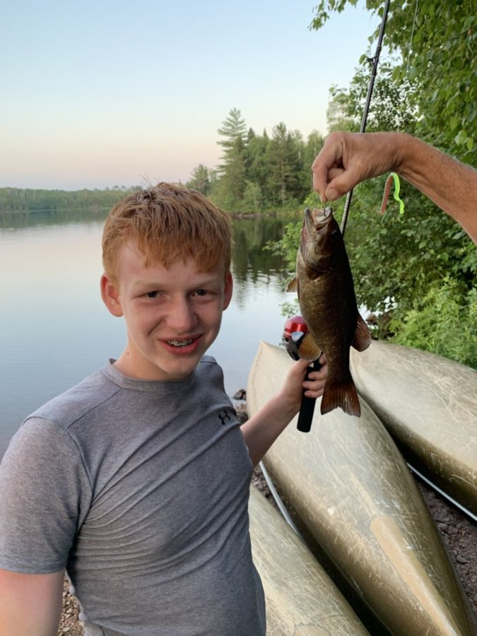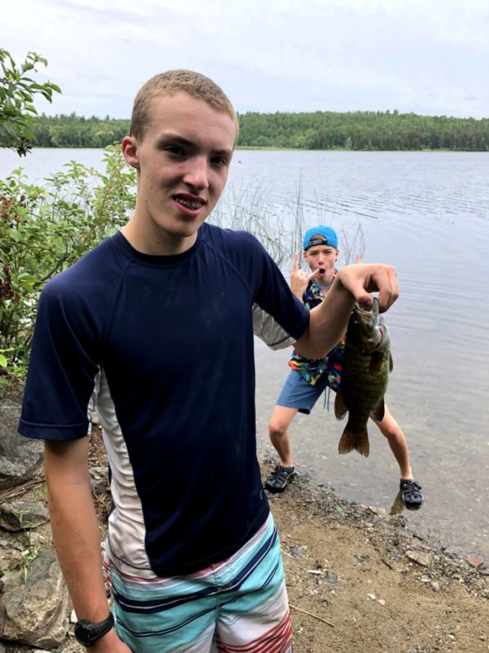
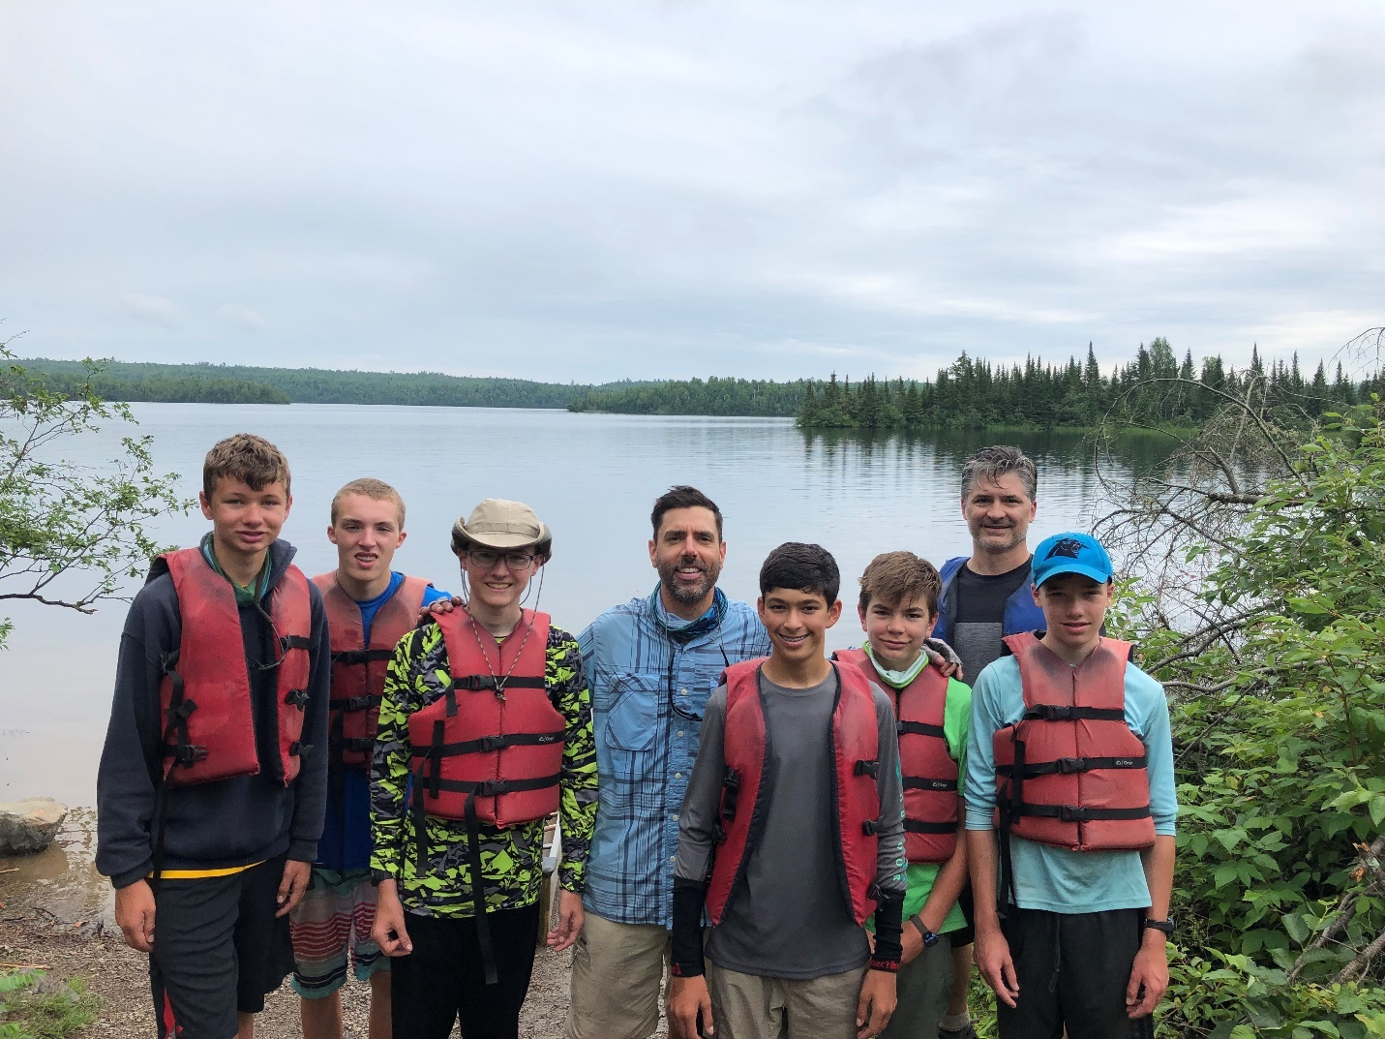
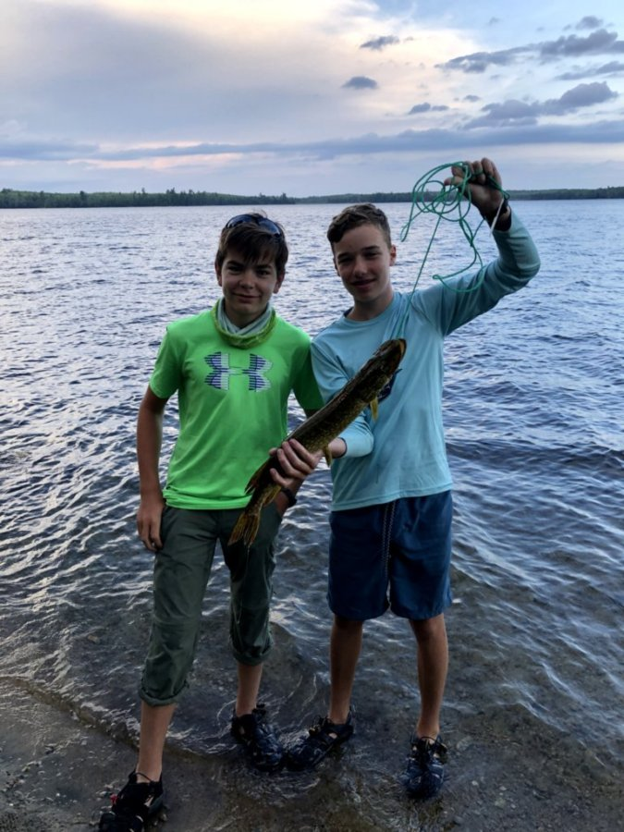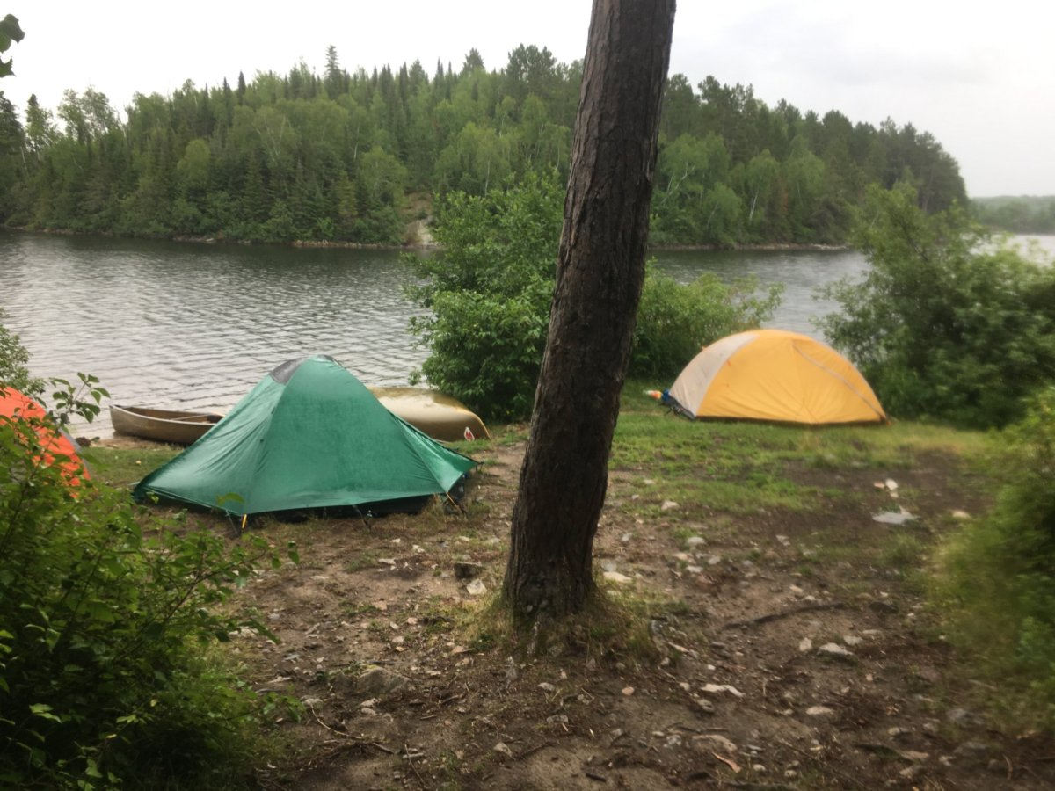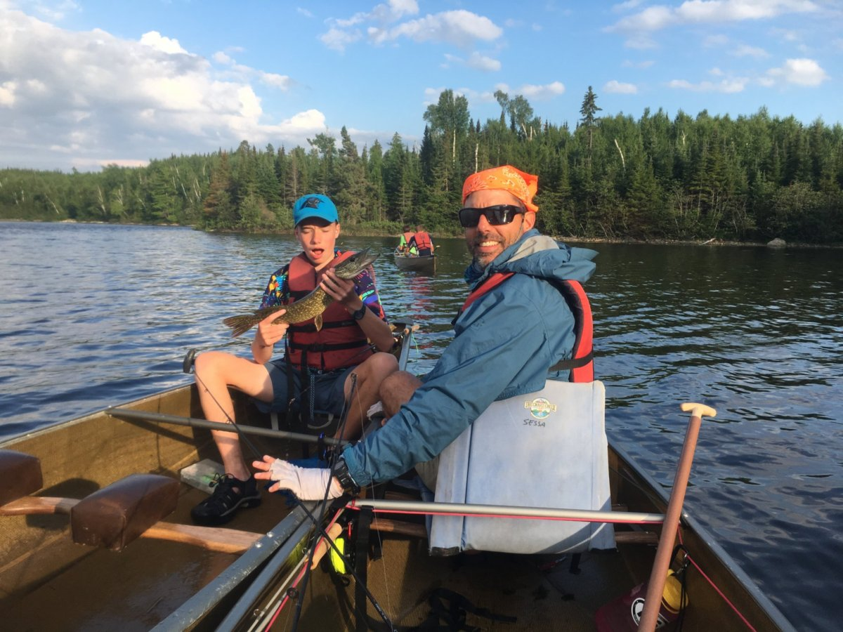

Frying up the catch!
