BeAScout.org
MANDATORY
REQUIRED
geographic pin

BeAScout.org is a website. It can be the initial introduction that a family receives when searching for information about scouting. The website offers information about Cub Scouts, Scouts BSA, Venturing Crews and Sea Scouting. It also reviews the steps to joining as well as a way to search for volunteer opportunities. At the bottom of the page there is even a brief FAQ section.
Most importantly though, BeAScout.org permits a family to geographically search, by zip code, for a scouting unit near them. The website has a drop down box “Find Scouting Near You” that will allow a prospective scouting family to enter their zip code and, after selecting the scouting unit they want to find (pack, troop, crew or sea scout), will return a either a list of scouting units or a map with Google-like pins.
The map below is a mock example of search results using the BeAScout.org website.
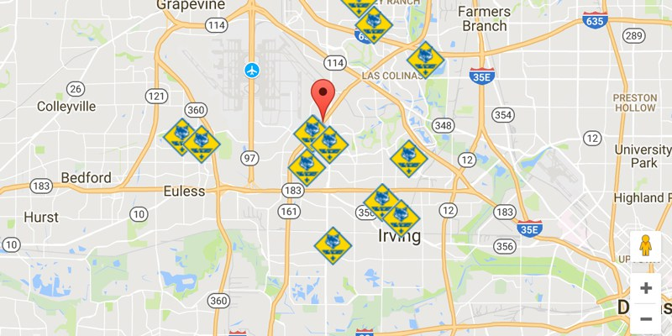
If your unit doesn’t have a pin, you cannot be located. So please, create a pin for your respective unit. This is a requirement for recruiting. Please ask your District Executive for assistance if you do not have a pin.
If your unit has a pin, it needs to be updated. From their search, the parents will know the what and where about you. Now they will need to know the who you are. Please update your pin with information you want prospective families to know. You can include meeting times, indicate that you are a “Family” scouting unit, mention highlights about your program, etc. Just provide something that will help a family learn enough about you to want to make the initial contact with you.
Use this link . . .
https://filestore.scouting.org/filestore/pdf/BeAScout_UnitPin_Management.pdf
to learn how to create and update your pin!

