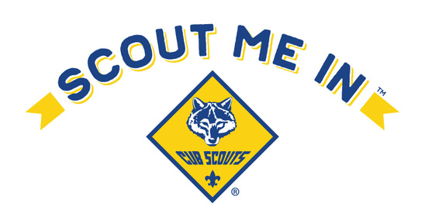
BEST PRACTICES FOR PACKS

- update BeAScout pins

- assign 3 key positions to support recruitment

- conduct an organizational meeting during July to plan for next year

- publish a calendar to advertise Pack activities and events

- update training records and complete appropriate training classes

- use appropriate forms of social media to establish an on-line presence

- plan/prepare a structured Charter Organization open house event

- communicate with new applicants about meeting dates, locations, times

- submit applications by District deadline

- host a virtual or in person parent orientation meeting for new families

- encourage leadership to attend Scouter Success Seminar

- encourage attendance at Trailblazer Adventure Day

- keep it simple and have FUN

